Art bible

In game buildings

Airport / Military scene buildings:

All buildings in this group have the same size in game:

Width = 296 pixels

Height = 171 pixels

Palette = Copper Radial, Cool Grey 11, Cool Grey 9, Black and Steel.



Palette = Dark Green, Steel, Black, Dark Brown and Green



Palette = Dark Cool Grey 11,Dark Cool Grey 9, Black, Dark Brown and Steel.



Palette = Dull Brass, Light Grey Brown, Medium Grey Brown, Brown, Black and Steel.



Scene buildings and assets:

All buildings in this group have the same size in game:

Width = 297 pixels

Height = 240 pixels

Palette = Cool Grey 11, Cool Grey 9 and Black.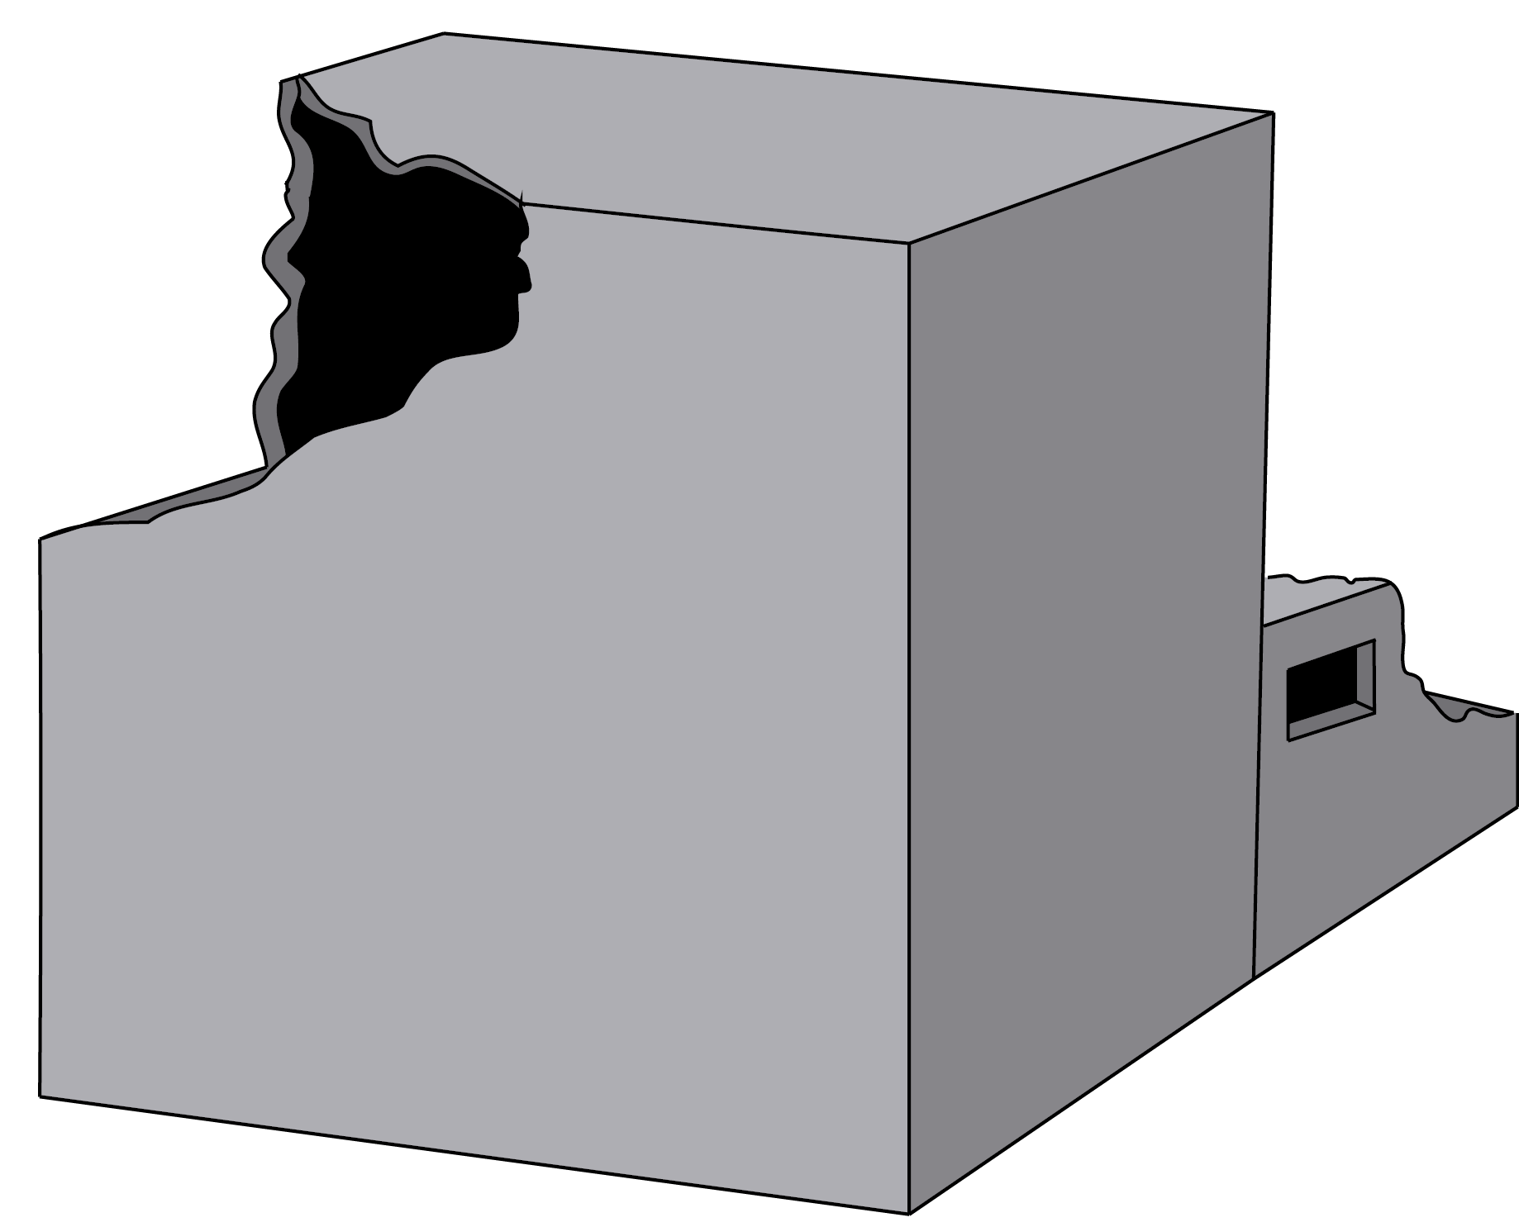

Palette = Dark Brown, Medium Brown, Peach- Yellow and Black.

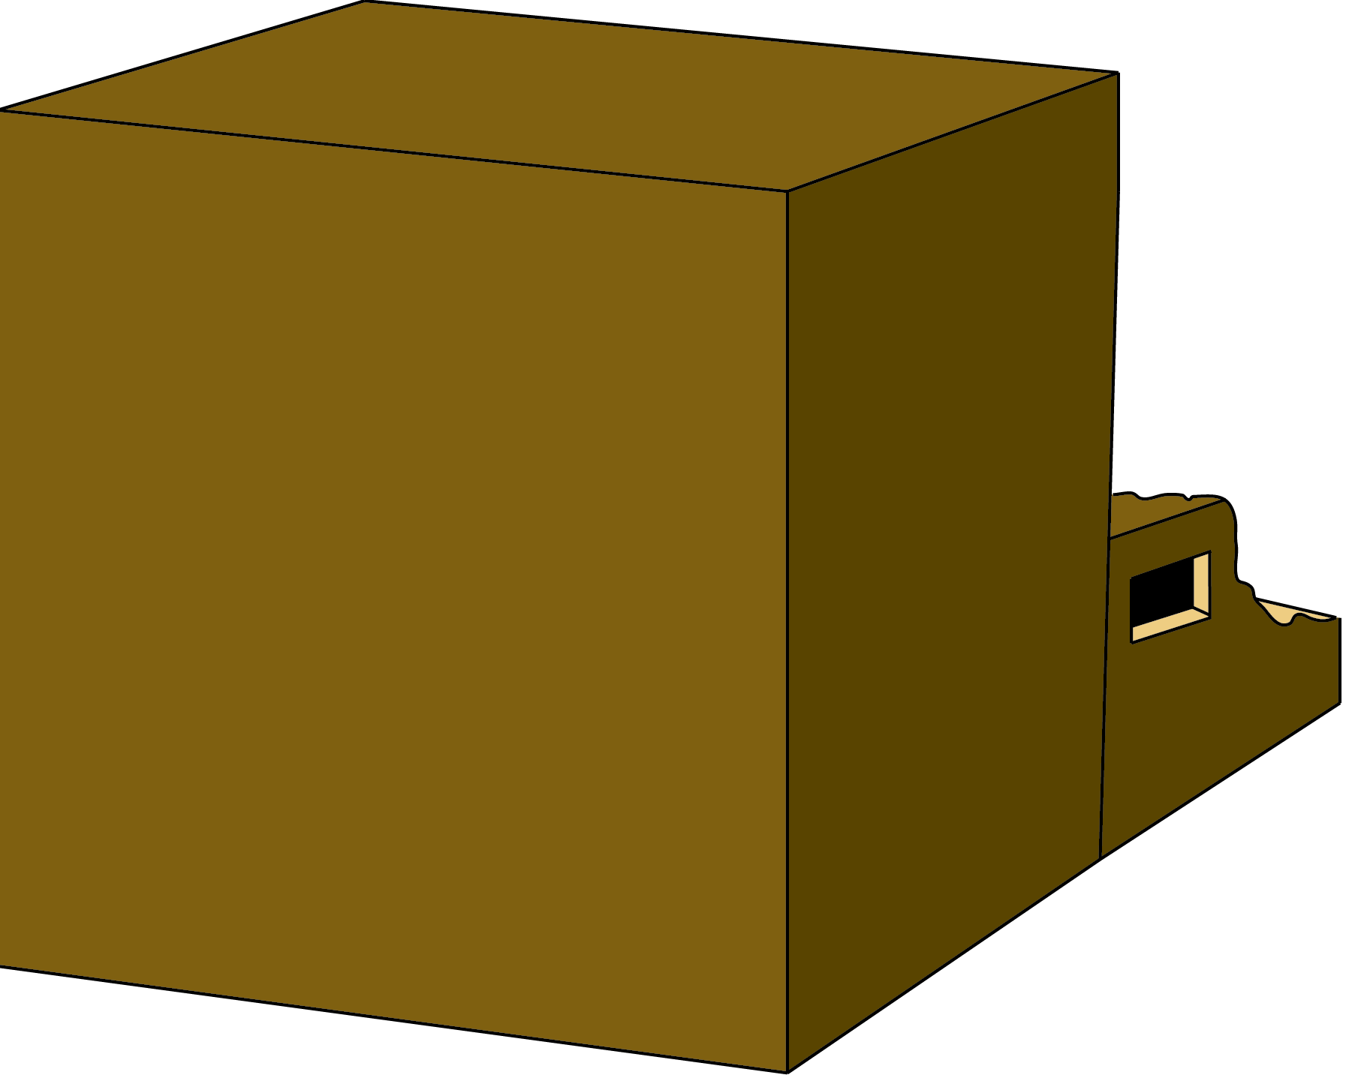

Palette = Peach- Yellow, Medium Peach- Yellow, Dark Peach- Yellow and Black.

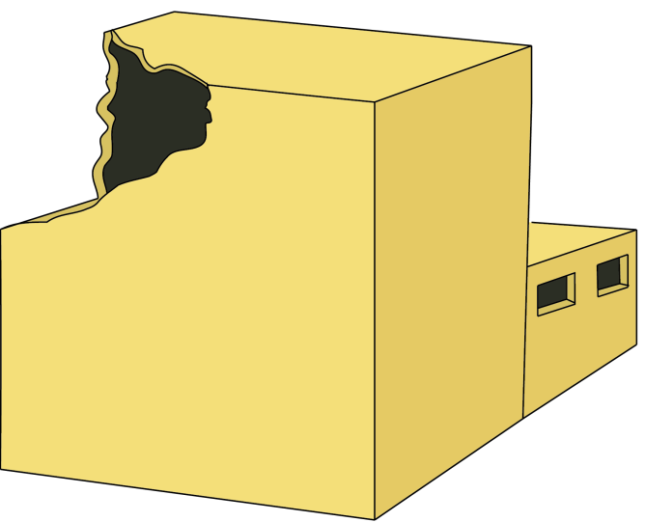

Palette = Light Grey Brown, Medium Grey Brown, Dark Grey Brown and Black.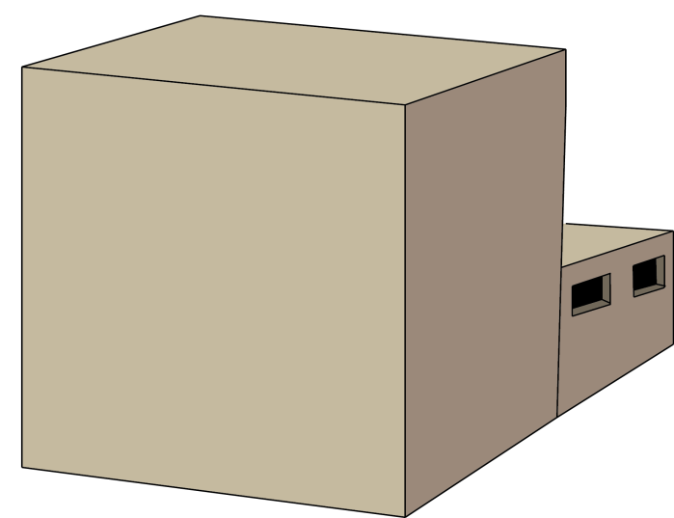

Assets:



Width: 290 pixels

Height: 157 pixels

Palette = Red, Dark Red, Grey, Steel and Black.





Width: 290 pixels

Height: 157 pixels

Palette = Blue, Dark Blue, Grey, Steel and Black.



Width: 290 pixels Width: 290 pixels

Height: 157 pixels Height: 157 pixels

Palette = Red, Dark Red, Grey, Steel Palette = Blue, Dark Blue, Grey, Steel

and Black. and Black.



Windows measures:

Width: 70 pixels

Height: 124 pixels

Palette: Light gradient blue, Black, Light Brown, Dark Grey.



Width: 224 pixels

Height: 164 pixels

Palette: Dark Brown, Light Blue Green





Width: 151 pixels

Height: 151 pixels

Palette: Light Brown



 Width: 149 pixels

Height: 181 pixels

Palette: Light Brown, Dark Green

 

Width: 176 pixels

Height: 138 pixels

Palette: Light gradient blue,

Light Grey Brown, Medium Grey Brown.

Width: 130 pixels

Height: 138 pixels

Palette: Light gradient blue,

Light Grey Brown, Medium Grey Brown and Black.





Width: 176 pixels

Height: 138 pixels

Palette: Dark Red, Grey, Dark Grey.

Width: 176 pixels

Height: 138 pixels

Palette: Dark Red, Grey, Dark Grey.



Width: 87 px Height: 114 px

Palettes: Dark Green



Width: 75 px Height: 62 px

Palette: Yellow Green



Width: 57 px Height: 45 px

Palette: Dark Grey

Scene Streets:



Width: 1024 pixels

Height: 493 pixels

Palette: Dark Grey, Medium Black, Dark Yellow, Grey, Brown and Green.